**Journal #2 - Samsung s III**

* *Nov 21, 2024*

**PostmarketOS**

Research possible solution ([postmarketOS-wiki](https://wiki.postmarketos.org/wiki/Samsung_Galaxy_S_III_(samsung-m0)#Installation%5C))

Before beginning this endeavor, make sure you meet the following requirements ([postmarketOS-install](https://wiki.postmarketos.org/wiki/Installation))

* Make sure your phone is listed among the [Devices](https://wiki.postmarketos.org/wiki/Devices) page, otherwise you’ll need to port your own system
* Pick between a stable version, or experimental edge release

**=== Trial 1 ===**

* Download the compressed software image file

For this section, you’ll need to select your preferred interface from the ones provided on postmarketOS site ([postmarketOS-interface-versions](https://images.postmarketos.org/bpo/v24.06/samsung-m0/))

* [Gnome-mobile](https://images.postmarketos.org/bpo/v24.06/samsung-m0/gnome-mobile/) - Chosen option, since we are more familiar with Gnome interface

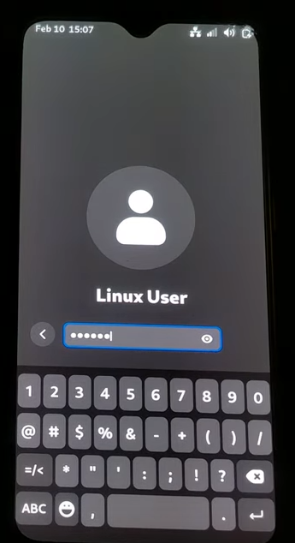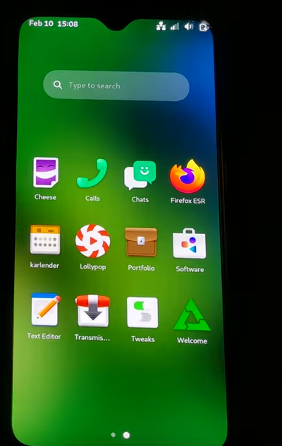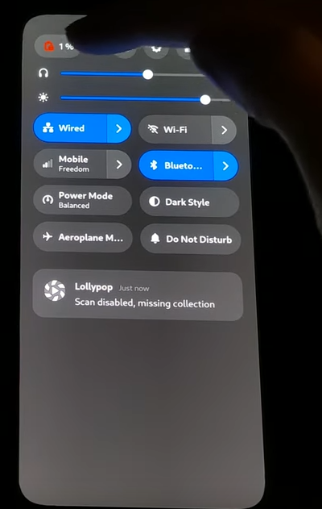

* [Phosh](https://images.postmarketos.org/bpo/v24.06/samsung-m0/phosh/) - version derived from Gnome

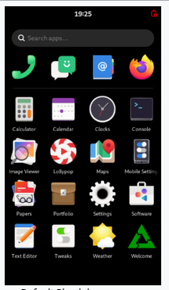

* [Plasma-mobile](https://images.postmarketos.org/bpo/v24.06/samsung-m0/plasma-mobile/) - Appearance like typical Android Distributions, still ugly

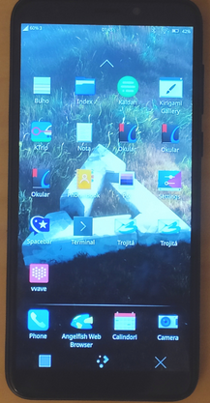

* [Sxmo-de-sway](https://images.postmarketos.org/bpo/v24.06/samsung-m0/sxmo-de-sway/) - Lacking visual documentation, personally unappealing as it feels more like operating a computer rather than a mobile device

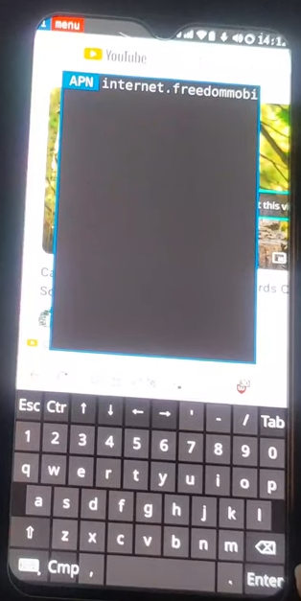

* Extract the software image file

Download the boot image, and system image related to your interface version. In my case I used ([postmarketOS-gnomemobile-imgs](https://images.postmarketos.org/bpo/v24.06/samsung-m0/gnome-mobile/20241120-1810/)) which I will provide in the extras folder.

Then unzip the file using 7-zip, since it is an image file meaning a standard unzip will not work:

*$ sudo apt install p7zip-full*

*$ cd /path/to/your/file*

*$ 7z x image/path.7z*

Note that the following steps from here did not work for my initial trial, however they are the closest steps I took to a solution. I will expand on this in later trials.

* Install heimdall for connectivity through Android Odin Mode

*$ sudo apt install haimdall-flash*

* Turn your phone into Download Mode

Hold Down volume, Home, and Power for a short while. This should activate Odin/download mode, here you may manipulate boot conditions for your device.

* Verify device connectivity to your computer

*$ sudo heimdall detect*

Should return that your “device connected”

*$ sudo heimdall print-pit –no-reboot*

print-pit is significant as it allows you to access your phone’s pit file. It isn’t used in these steps but I’m certain more could be done with it in later trials

* Install boot using the the boot.img file

Now that your image files are on your computer, run the following commands.

*$ sudo heimdall flash --BOOT /boot/image/path/20241120-1810-postmarketOS-v24.06-gnome-mobile-2-samsung-m0-boot.img –verbose –no-reboot*

* Install system using full system .img file

*$ sudo heimdall flash --SYSTEM /system/image/path/20241120-1810-postmarketOS-v24.06-gnome-mobile-2-samsung-m0.img –verbose –no-reboot*

In theory, these last 2 commands should allow your device to install and boot your postmarketOS version. However, there seemed to be issues with specifying the PIT (Partition Information File) in the command. By default, these commands should allow you to bypass these specifications without needing to declare the PIT file location in the command. But here is where I encountered my problem, as once that doesn’t work, I found difficulty in retrieving the PIT file directly. I tried adding the “--pit s3.pit” tag in the command, which yielded the same results. For next time, I will attempt running:

*$ sudo heimdall download-pit --output <filename>.pit --verbose*

This will hopefully allow me to access it directly, which might have been the missing step in the last trial.

What I’ve noticed is that the steps did not include flashing an SD card with the image files, nor did it involve any partitioning. Next time I’ll attempt to do that instead, which will require further documentation, since this isn’t anything I can find online for my specific case.